**Assignment-2**

**Patel Shahil Manishbhai – 200010039**

**30th August 2022**

1. The following table contains all the integrity constraints for each table definition in the university schema.

|  |  |  |  |  |
| --- | --- | --- | --- | --- |
| **Table** | **Primary Key** | **Domain of PK** | **Foreign Key** | **Not NULL** |
| classroom | building, room_number | varchar | None | building, room_number |
| department | dept_name | varchar | None | dept_name, budget |
| course | course_id | varchar | dept_name (*references department*) | course_id, credits |
| instructor | ID | Varchar | dept_name (*references department*) | ID, name, salary |
| section | course_id, sec_id, semester, year | varchar, numeric | course_id (*references course*), building, room_number (*references classroom*) | course_id, sec_id, semester, year |
| teaches | ID, course_id, sec_id, semester, year | varchar, numeric | course_id, sec_id, semester, year (*references section*), ID (*references instructor*) | ID, course_id, sec_id, semester, year |
| student | ID | varchar | dept_name (*references department*) | ID, name |
| takes | ID, course_id, sec_id, semester, year | varchar, numeric | course_id, sec_id, semester, year (*references section*), ID (*references student*) | ID, course_id, sec_id, semester, year |
| advisor | s_ID | varchar | i_ID (*references instructor (ID)*), s_ID (*references student (ID)*) | s_ID |
| time_slot | time_slot_id, day, start_hr, start_min | varchar, numeric | None | time_slot_id, day, start_hr, start_min |
| prereq | course_id, prereq_id | varchar | course_id (*references course*), prereq_id (*references course*) | course_id, prereq_id |

1. Query used:

**SELECT** *  
**FROM** student s, department d, takes t, advisor a, instructor i  
**WHERE** s.name = ‘Brown’ **and** s.id = t.id **and** s.id = a.s_id **and** a.i_ID =  
i.id **and** s.dept_name = d.dept_name;

Output:



1. The following answer contains 2 images for each table 1st before running the query and 2nd the output after running the query.
2. *Advisor*

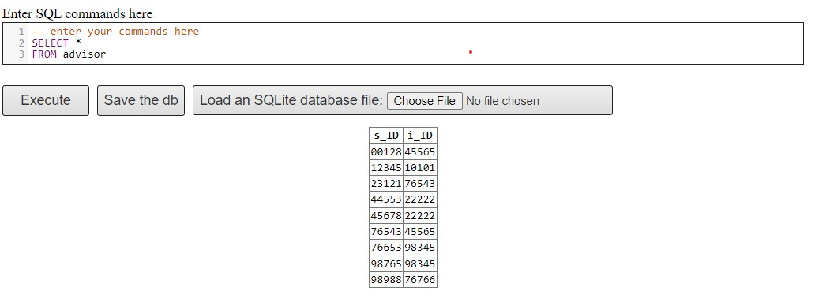

Figure 1 Advisor Table

Query:

**SELECT** s_id

**FROM** advisor

**WHERE** s_id%2 == 0

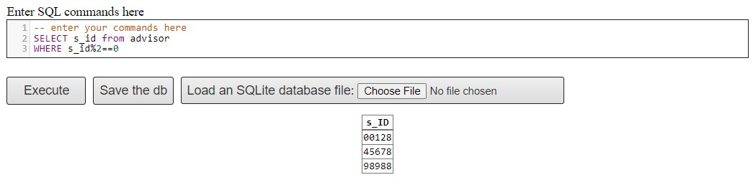

Figure 2 Output after running above query on Advisor

1. *classroom*

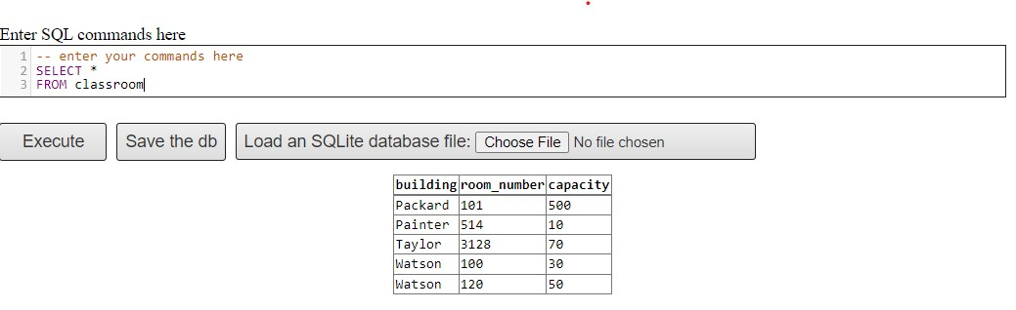

Figure 3 classroom table

Query:

**INSERT INTO** classroom

**VALUES** (‘IIT’, 2000, 150);

**SELECT** * **FROM** classroom

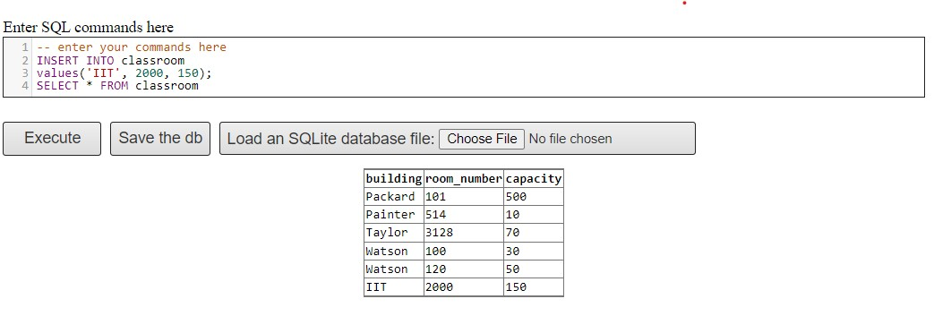

Figure 4 Output after running the above query

1. *course*

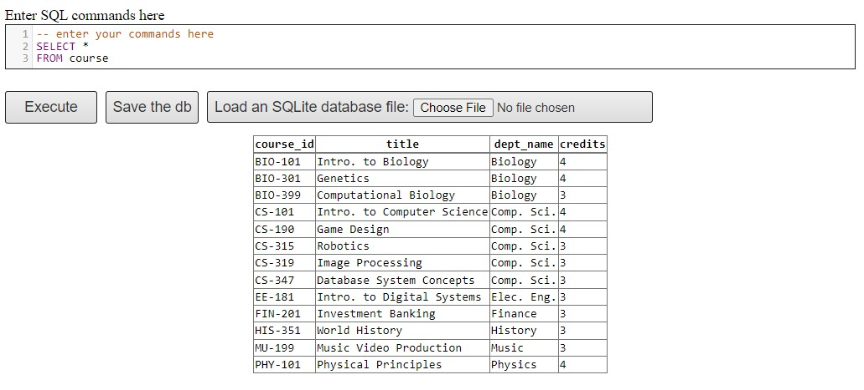Query:

Figure course table

**UPDATE** course

**SET** TITLE = Biology For Engineers’, credits = 6

**WHERE** course_id = ‘BIO-101’;

**SELECT** * **FROM** course

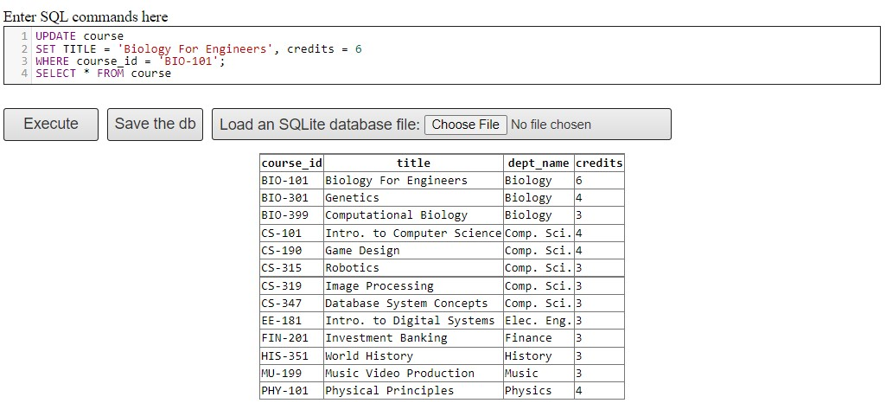

Figure 6 Output after running above Query

1. *department*

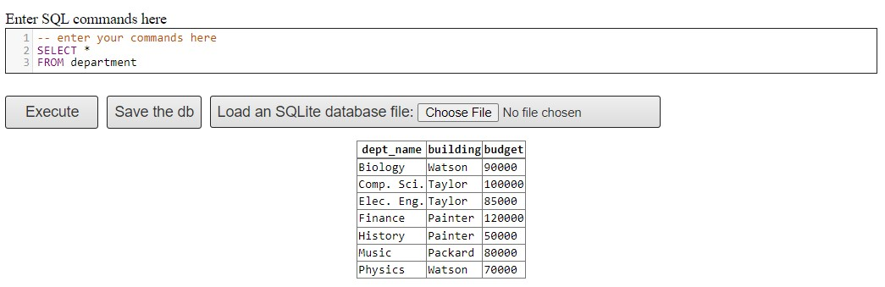

Figure 7 department table

Query:

**DROP TABLE** department

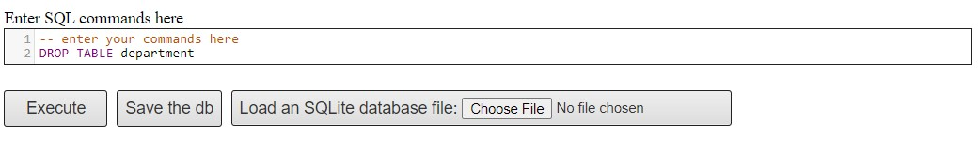

Figure 8 Output after running above query

1. *instructor*

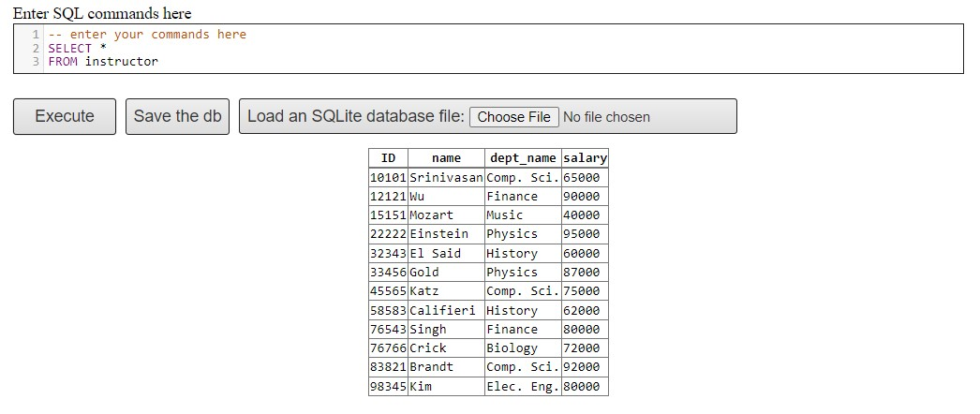

Figure instructor table

Query:

**DELETE FROM** instructor

**WHERE** salary=65000;

**SELECT** * **FROM** instructor

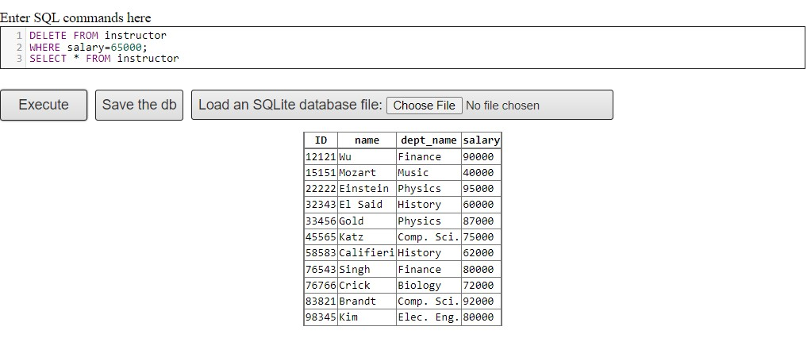

Figure Output after running above query

1. *prereq*

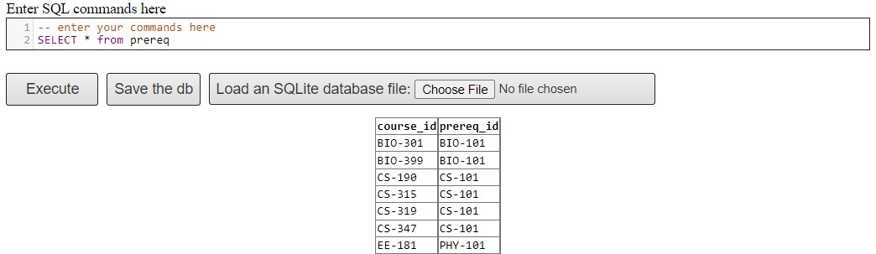

Figure prereq table

Query:

**SELECT** course_id

**FROM** prereq

**WHERE** prereq_id **LIKE** ‘C%’

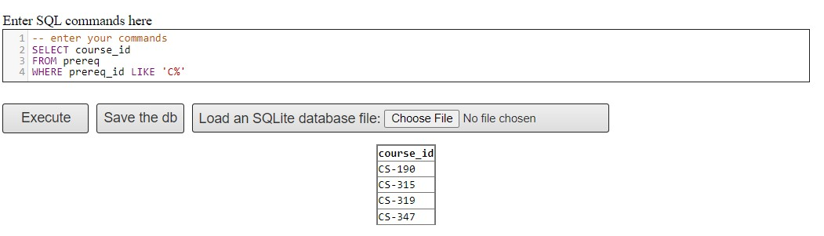

Figure output after running above query

1. *section*

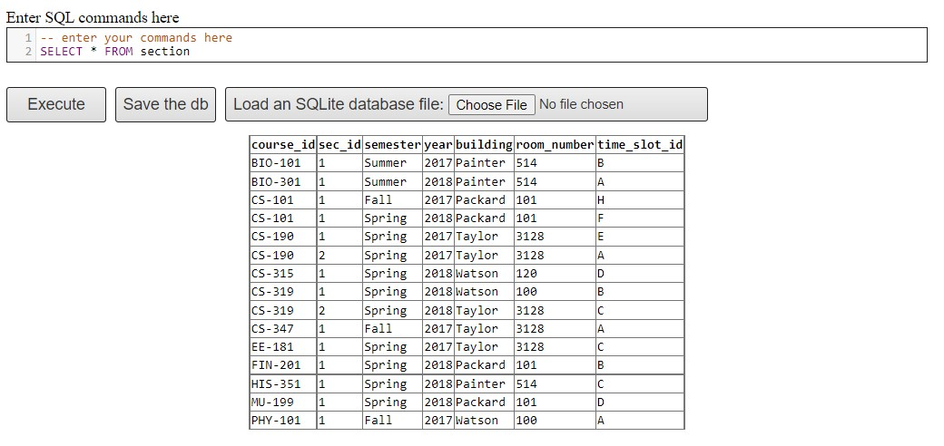

Figure section table

Query:

**DELETE FROM** section

**WHERE** semester = ‘Spring’ **and** room_number = 3128;

**SELECT** * **FROM** section

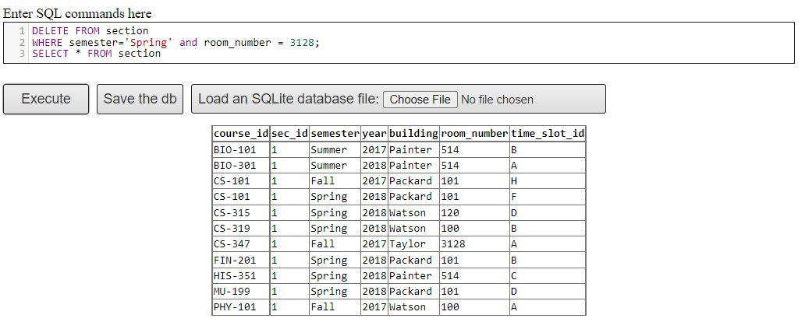

Figure output after running above query

1. *student*

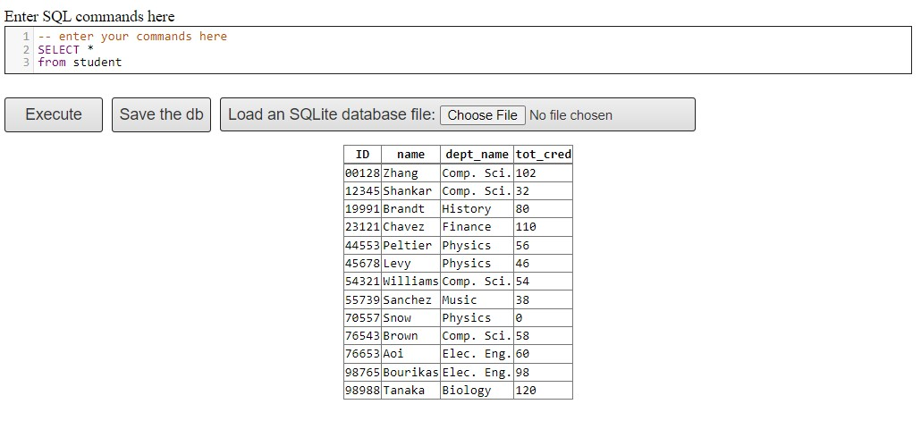

Figure student table

Query:

**SELECT** *

**FROM** student **ORDER BY** name

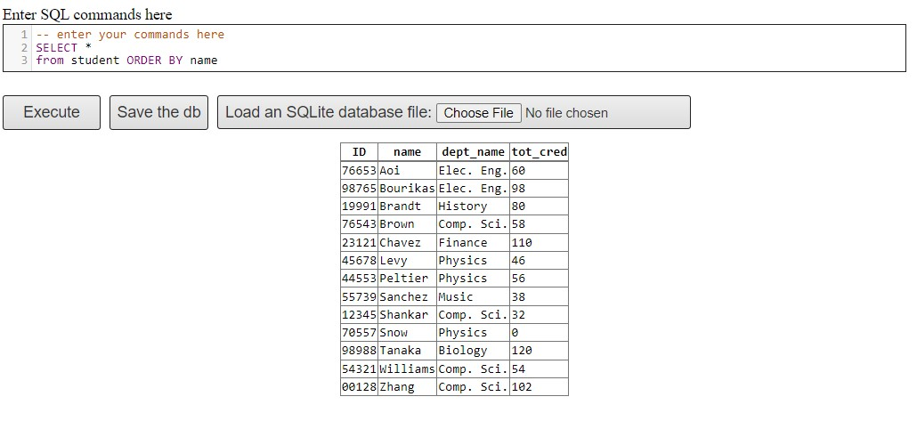

Figure result after running above query

1. *takes*

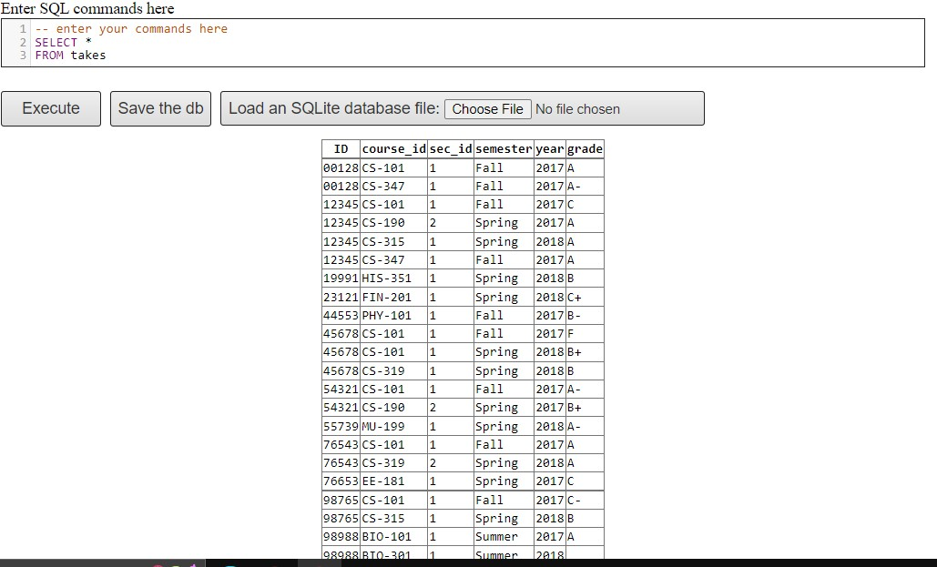

Figure takes

Query:

**ALTER TABLE** takes

**ADD** Result varchar (50);

**SELECT** * **FROM** takes

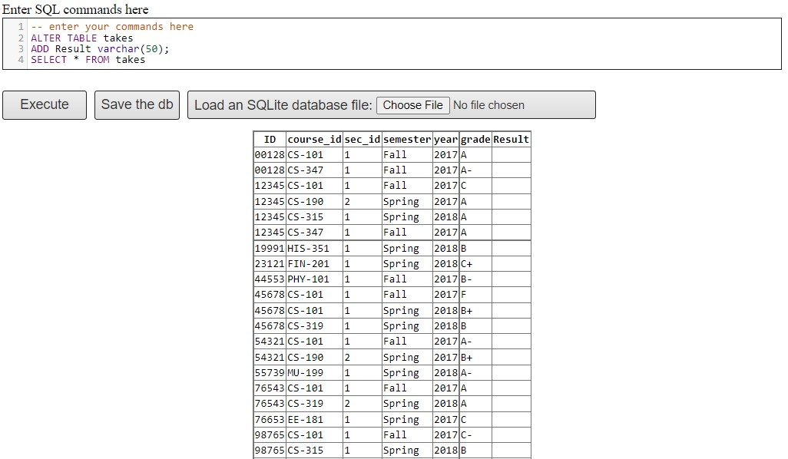

Figure output after running above query

1. *teaches*

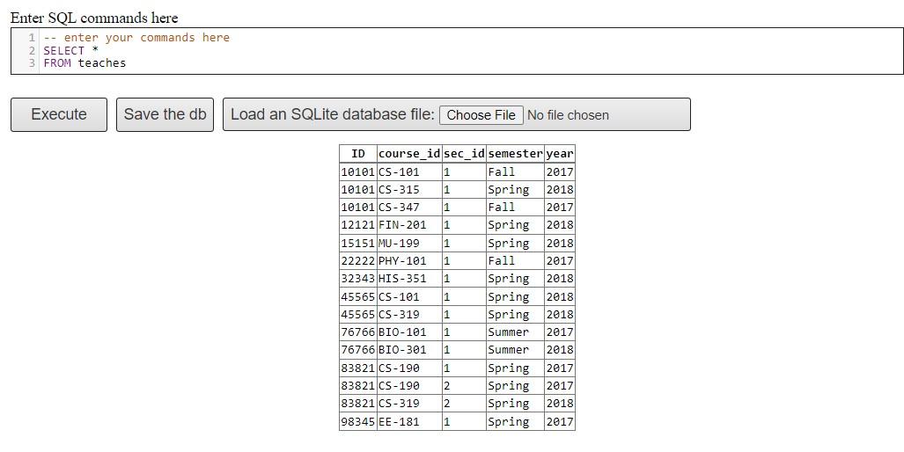

Figure teaches table

Query:

**SELECT** * **FROM** teaches **ORDER BY** year;

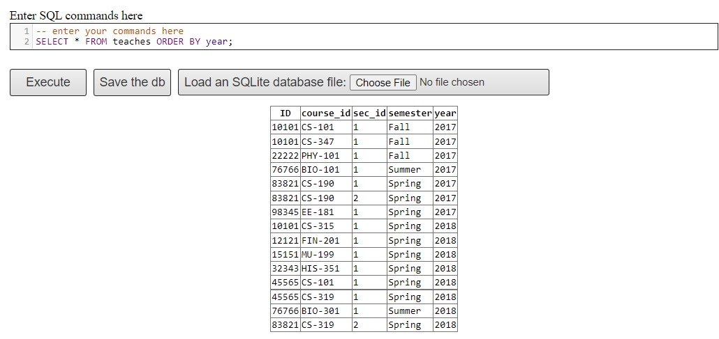

Figure output after running above query

1. *time_slot*

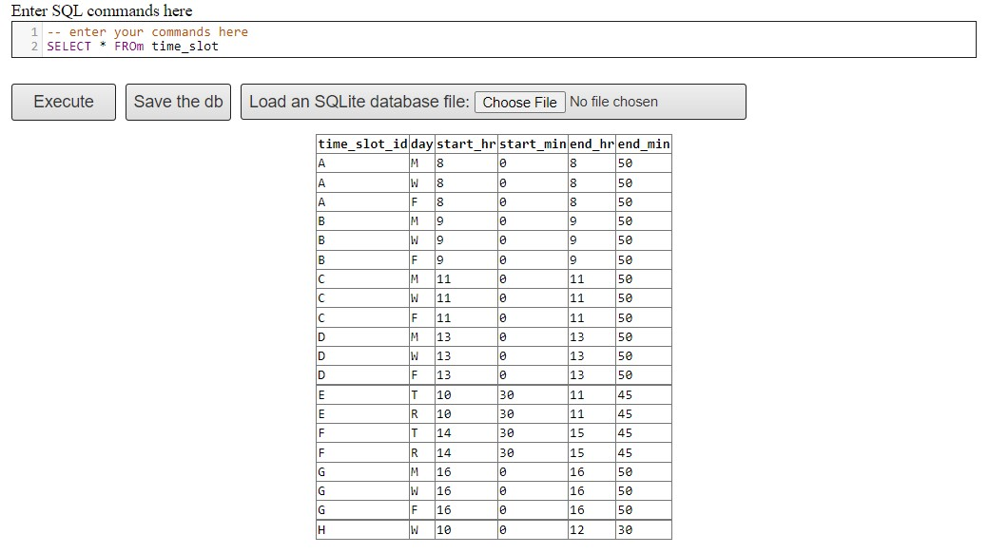

Figure time_slot table

Query:

**SELECT** time_slot_id, day

**FROM** time_slot

**WHERE** start_min = 0 **and** end_hr<10

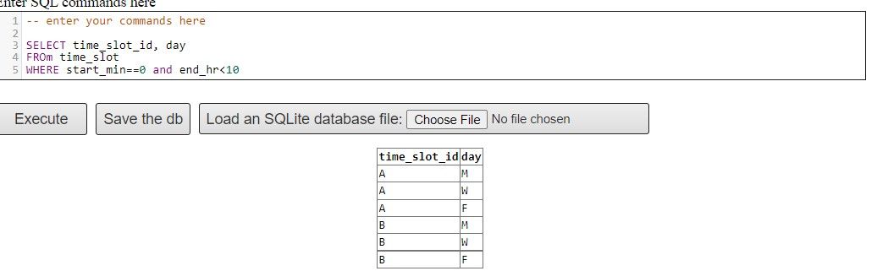

Figure output after running above query

1. a)

In these question I have taken xxx = ‘Music’ and yyy = ‘Packard’

Query:

**SELECT** **DISTINCT** student.ID, student.name

**FROM** student, department, section

**WHERE** department.dept_name = ‘Music’ **and** department.building = ’Packard’ **and** student.dept_name = department.dept_name and section.building = department.building

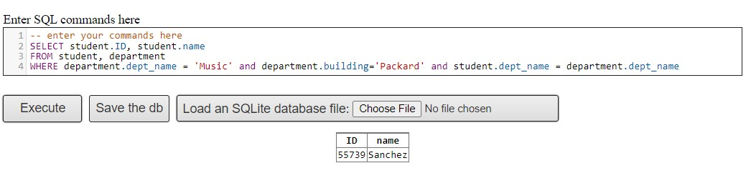

Figure Output

b)

Query:

**SELECT** student.ID, student.name

**FROM** takes, student

**WHERE** grade = ‘A’ **and** student.id = takes.id

INTERSECT

**SELECT** student.ID, student.name

**FROM** takes, student

**WHERE** grade = ‘C’ **and** student.id = takes.id

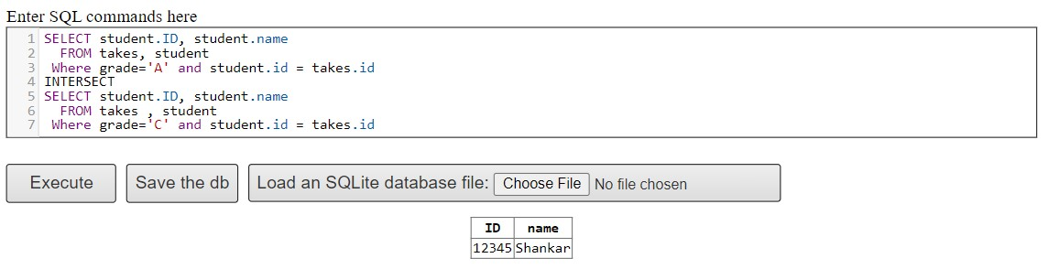

Figure output

c)

Query:

**SELECT DISTINCT** classroom.building, classroom.room_number

**FROM** section, classroom, time_slot

**WHERE** classroom.building = section.building **and** classroom.room_number = section.room_number **and** section.time_slot_id = time_slot.time_slot_id **and** day = ’W’

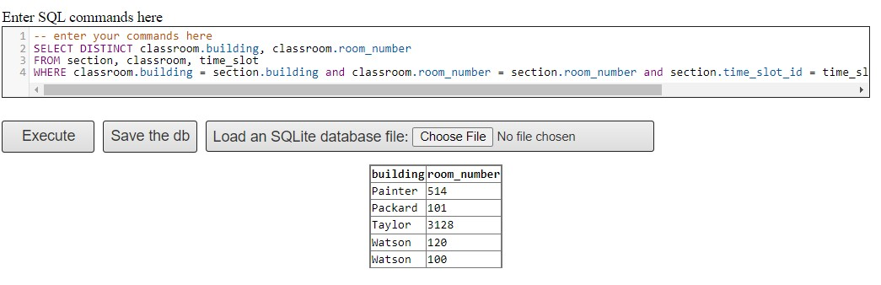

Figure output